|  |  |  |
| --- | --- | --- |
|  | **Nitte Meenakshi Institute of Technology**  (AN AUTONOMOUS INSTITUTION AFFILIATED TO VISVESVARAYA TECHNOLOGICAL UNIVERSITY, BELGAUM)  PB No. 6429, Yelahanka, Bangalore 560-064, Karnataka  Telephone: 080- 22167800, 22167860  Fax: 080 - 22167805 |  |

**COURSE REPORT (**SRS DOCUMENT)

On

**Airline Reservation System**

*Submitted in partial fulfilment of the requirement for the award of Degree of*

*Bachelor of Engineering*

*in*

*Computer Science and Engineering*

Submitted by:

|  |  |
| --- | --- |
| SAILESH PANDEY | 1NT18CS201 |
| MANAN VANAWAT | 1NT18CS091 |

Under the Guidance of

**Mr. Sathish EG**

Assistant Professor, Dept. of CS&E, NMIT

**Department of Computer Science and Engineering**

**(Accredited by NBA Tier-1)**

**2020-2021**

|  |  |  |
| --- | --- | --- |
|  | **Nitte Meenakshi Institute of Technology**  (AN AUTONOMOUS INSTITUTION AFFILIATED TO VISVESVARAYA TECHNOLOGICAL UNIVERSITY, BELGAUM)  PB No. 6429, Yelahanka, Bangalore 560-064, Karnataka  Telephone: 080- 22167800, 22167860  Fax: 080 - 22167805 |  |

**Department of Computer Science and Engineering**

**CERTIFICATE**

This is to certify that the Course Project titled “AIRLINE RESERVATION SYSTEM” is an authentic work carried out by **SAILESH PANDEY(1NT18CS201), MANAN VANAWAT (1NT18CS091)** students of **NITTE MEENAKSHI INSTITUTE OF TECHNOLOGY**, Bangalore in partial fulfilment for the award of the degree of **Bachelor of Engineering** in COMPUTER SCIENCE AND ENGINEERING of Visvesvaraya Technological University, Belagavi during the academic year ***2020-2021.***

**Internal Guide** **Signature of the HOD**

|  |  |  |  |
| --- | --- | --- | --- |
|  | **Mr. SATISH EG** | **Dr. Thippeswamy M. N.** |  |
|  | **Assistant Professor, Dept. CSE,** | **Professor, Head, Dept. CSE,** |  |
|  | **NMIT, Bangalore** | **NMIT, Bangalore** |  |
|  |  |  |  |

**DECLARATION**

This is to certify that:

* The project work is our original work.
* This Project work has not been submitted for the award of any degree or examination at any other university/College/Institute.
* This Project Work does not contain other persons’ data, pictures, graphs or other information, unless specifically acknowledged as being sourced from other persons.
* This Project Work does not contain other persons’ writing, unless specifically acknowledged as being sourced from other researchers. Where other written sources have been quoted, then their words have been re-written, but the general information attributed to them has been referenced; where their exact words have been used, their writing has been placed inside quotation marks, and referenced.
* This Project Work does not contain text, graphics or tables copied and pasted from the Internet, unless specifically acknowledged, and the source being detailed in the thesis and in the References sections.

**ACKNOWLEDGEMENT**

The satisfaction and euphoria that accompany the successful completion of any task would be incomplete without the mention of the people who made it possible, whose constant guidance and encouragement crowned our effort with success. we express our sincere gratitude to our Principal **Dr. H. C. Nagaraj**, Nitte Meenakshi Institute of Technology for providing facilities.

We wish to thank our HOD**, Dr. Thippeswamy M.N** for the excellent environment created to further educational growth in our college. We also thank him for the invaluable guidance provided which has helped in the creation of a better technical report.

Thanks to our Subject Faculty. We also thank all our friends, teaching and non-teaching staff at NMIT, Bangalore, for all the direct and indirect help provided in the completion of the presentation. Lastly, we thank to our parents for supporting, encouraging and loving us.

**ABSTRACT**

This SRS document presents a detailed description of the Airline Reservation system. Airline reservation System is a computerized system used to store and retrieve information and conduct transactions related to air travel. The project is aimed at exposing the relevance and importance of Airline Reservation Systems. It is projected towards enhancing the relationship between customers and airline agencies through the use of ARSs, and thereby making it convenient for the customers to book the flights as when they require such that they can utilize this software to make reservations. The airline booking website is an application stored in the user server. The purpose of the website is to resolve the client to allow website users to perform tasks related to booking an airline flight. Non-member users are only allowed to search for available flights; non-member users are required to create an account in order to reserve a seat or to book a flight. Member users have the right to search for available flights, to reserve a seat, to book a flight, cancel a flight and to edit their member information. Member users are required to login into their account prior to flight booking.

**INTRODUCTION**

This SRS document presents a detailed description of the Airline Reservation System. It represents the client requirements analysis that defines the functional and non-functional requirements of the airline website and its different functionalities. It defines the abilities, reactions from stimuli, guidelines and limitations of the system. This document will be complete in its scope of the system and the functions required. The system provides a solution to allow the user to search for flights satisfying the user criteria, to reserve seats, to manage the user account, and to book a flight.

**DESCRIPTION: -**

**Product Perspective:**

This project represents the initial version of the Airline Reservation system. All requirements listed herein describe a self-contained system. At a high level, this project will allow a user to book flights, check flights, do account maintenance, and query flight information. The goal is to allow customers greater and easier access to the airline’s booking system, twenty-four hours a day.

**Product Features:**

We can subdivide the project into 8 main features.

1. *Login*

This function allows a registered user to login his account using his frequent flyer number with the airline and password. If a user is not registered, the website shall allow the user to enroll first. The system will check both the frequent flight number and password, when a user attempts to login.

Reason: This provides security to the system by authenticating each member and provides confidence to the consumer that his/her personal information is secure.

1. *Enrollment*

This function allows unregistered user to enroll and to create a new account with the website. In order to create a new account, the user has to provide required information such as first name, last name, email address and password. Other optional information, such as phone number, credit card information and mailing address, can be provided during the registration process. The system checks if all required data are provided and then will prompt the user to enter additional information, if required. After all required information is provided, the system auto-generates a unique frequent flyer number that the user must use as username for future authentications. The system shall auto-generate this number in less than five seconds.

Reason:

A user who wishes to purchase flights and use advanced features, must be logged in. However, without enrollment, a user can never be a member. This section offers all users a chance to become a member.

1. *Book Flights*

The user can use the function to purchase seats for an airplane flight. The system shall present the user with information on all current flights. The user may then select a pair (departure and return) of flights on which to purchase seats. The user can indicate the number of seats and placement of such. Finally, the system shall guide the user completely through the checkout process.

Reason:

The heart of the business is selling seats on flights. This section provides the primary source of system transactions.

1. *Reserve Seats*

The user can use the Reserve Seat function to reserve seats for an airplane flight. The seats to be reserved are initially found through the user’s previous bookings. These bookings were previously completed through the Book Flight function. The system shall display available seats for the departing and returning flights booked by the user. The user selects seats from each flight, where the number of selected seats from each flight is the number that the user booked on that particular flight. Once the flight seats are selected, the user confirms the seat selection.

Reason:

Customers prefer to know where their seats are located. Further, they prefer to pick out particular seats – closer to the front, window seat, aisle seat, etc.

1. *Flight status:*

This section shall allow the user – whether enrolled or not – to view flight information that matches input criteria. The user will provide:

1. A flight number and date

or

1. Departing/Arriving Cities and Date.

The system will display matching flight information including the following fields,

•Flight Number

•Departure City

•Arrival City

•Status (one of the following)

* In Flight
* At the Gate
* Delayed
* On Time

Reason:

Users will want to query the system to find flight information, even if they’re not at an airport (e.g., on their mobile phone). By making this information available through the web site, we can provide an extra service to the customer and increase our company’s value.

1. *Flight Schedules*

This section of the system shall allow a user to query flight schedules based upon simple input criteria. The user will provide departure and arrival cities, and a departure/return date. If any flights match the criteria, the system will display the following information:

* Flight Number
* Departing City & Date/Time
* Arriving City & Date/Time
* Number of Available Seats.

The system shall define a “matching” flight as one that uses the departure/arrival cities at a flight time greater or equal to the time provided by the user. Otherwise, the system shall alert the user that no matching flights can be found.

Reason:

A customer will want to book flights based on his/her travel plans .This section provides the user a choice of available flights from which to pick.

1. *My account:*

This section gives the user the power to view, save, edit or delete the information stored in his/her account. The user can check his/her accumulated points, look at the status of a flight that was booked, cancel a flight that was already booked (optional) and change his/her address, phone number, email or password. This feature is not available for non-registered user.

Reason:

A customer’s information changes from time to time. Giving the usersa way to modify their account information allows the business to have current & updated information.

1. *Logout*

The Logout section provides a way for the user to securely log out of the system. This process will save all user operations when he/she exits the system. If a user wishes to continue accessing the website, he/she must log-in again to access user features.

*Reason:*

Customers often use shared computers. Providing a way to clear state and log-out gives our customers confidence that nobody else will use their flight-booking session.

**System features:**

*Requirements:*

Login:

Inputs: Frequent flyer number and password

Source: All inputs are provided by user.

Outputs: Indication that user is logged in to the system.

Destination: The outputs are displayed on the screen as well as stored in the system.

Requires: The user provides login information including frequent flyer number and password.

Pre-Conditions: User is not logged in to system. User has previously enrolled in system.

Post-Conditions: User is logged in to system, OR user is not logged in because he/she entered unrecognized information.

Side-Effects: None

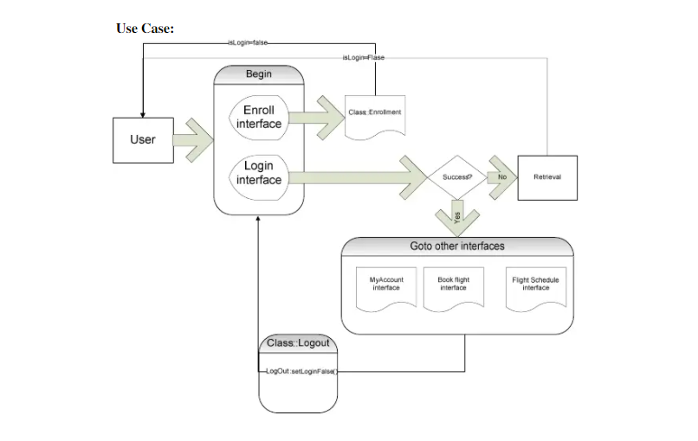

Enrolment:

Inputs Required: First name, last name, email address and frequent flyer

Optional: phone number, credit card information and mailing address.

Source: All data except the frequent flyer number are inputs from the user. The frequent flyer number is from the system store.

Outputs: Frequent Flyer Number

Destination: The changes are committed on the completion of the “enrolment” function to account information. All information also displays to the user via the screen.

Pre-Conditions: The user must not have an existing account with the website.

Post-Conditions: A user account is created and the user is able to access all functionalities provided by the function “My Account”.

Side-Effects: None

Book flights:

Inputs: User information – the user must already be logged in.

Source: Inputs are from the user except flight information, which is retrieved from the system.

Output: The purchased seats are tied to the user’s account, so he/she can reserve seats later.

Destination: The booked flights will be stored in the user’s account information when the user finishes payment. The flight information shall also display on the screen.

Pre-Conditions: The user must have an account with the website and must be logged in.

Post-Conditions: Completion of this function guarantees that the user has seat son a specific flight. However, if the user wants particular seats, he/she must also complete the reserve seats function. Any successfully-booked flight from this function is assumed to have completed payment already.

Side-Effects: User’s account is charged. Flight is associated with user’s account.

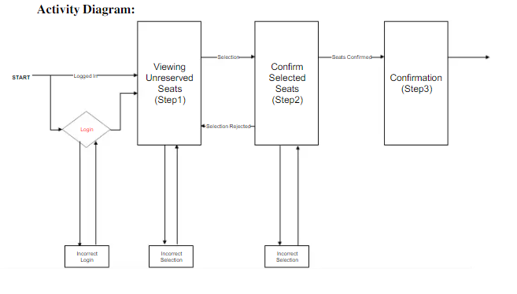

Reserve Seats:

Inputs: User information used to determine previously booked flights. Selected seats will be reserved by user.

Source: Inputs are from the user except flight information, which is retrieved by the system.

Outputs: Selected Seats

Destination: The changes are committed on completion of the

Reserve Seats function to the user’s account information. The selected seats are also displayed to the screen.

Pre-Conditions: The user must have an account with the website and must be logged in. The user must also have previously booked flights without seats reserved, either by user or system.

Post-Conditions: All selections of seats must be applied to the user’s account.

Side-Effects: The selected seats are no longer available to any other customer.

Flight Status:

Inputs: Departing city, Destination city, Departure date/time

Source: All inputs are provided by the user.

Outputs: Flight information including Flight Number, Departure City, Arrival City, and Flight Status.

Destination: All outputs should display on the screen.

Pre-Conditions: None.

Post-Conditions: User has flight status for any matching flight.

Side-Effects: None

Flight Schedule:

Inputs: Departing City, Destination City, Departure Date/Time

Source: All inputs provided by user.

Outputs: Flight Information including Flight Number, Departing City &Date/Time, Arriving City and Date/Time, Number of Available Seats.

Destination: All output should display to the screen.

Pre-Conditions: None

Post-Conditions: User has flight information for any matching flight.

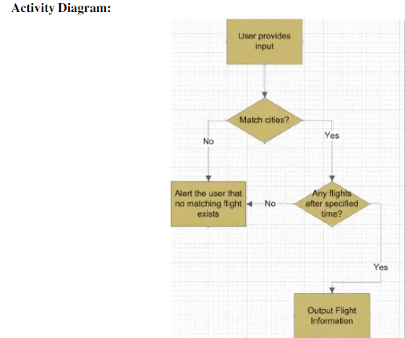

My Account:

Inputs: Account changes, if any, made by the user. Account changes include updates on first name, last name, email address, mailing address, password or phone numbers.

Source: All data are inputs from user.

Output: None.

Destination: The changes are committed on completion of the My Account function to account information.

Pre-Conditions: The user must have an account with the website and must be logged in prior to access his/her account.

Post- Conditions: All changes submitted by the user are applied to the user account on completion of the function.

Account Log out:

Inputs: None.

Source: N/A

Outputs: Notification that the user is logged out.

Destination: User is notified by display to screen.

Pre-Conditions: User is logged in to the system.

Post-Conditions: User is logged out of the system.

Side-Effects: The system clears the session state for the user once logout is complete.

**External Interface Requirements**

User Interfaces

A Help link will appear on every screen that describes the function of each page to the user. The implementation should be written so that blind users can still interact with the system (using a screen reader.)

Communications Interfaces

The system must utilize the standard Hyper Text Transfer Protocol (HTTP) to ensure maximum inter-browser compatibility. The client accesses the system through a web browser.